SOROPTIMIST LIVE YOUR DREAM AWARD
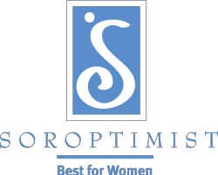

The Soroptimist Awards program was established in 1972 to assist women with primary financial responsibility for their families to obtain the skills-training and education necessary to improve their employment status and standard of living for themselves and their family. Each year, $1.5 million in club, region and international funds are awarded to more than
1,500 women in Soroptimist’s 19 member countries and territories. The women receiving these financial awards may use them for any costs associated with their educational efforts, including tuition, books, child care, and transportation. The chosen recipient of SI Oakland County Live Your Dream Award will also be considered for additional awards at the regional and international levels.

Would you like to receive $1500.00 towards your educational efforts? See if you qualify.

PLEASE CHECK ALL THAT APPLY

 I have a U.S. Social Security Number (this requirement applies to
U.S. applicants only)
 I earn the most money in my household
 I support at least one of the following: child spouse parent
sibling other dependent
 I am enrolled in a vocational/skills training program or an undergraduate degree program
 I am willing to describe my educational and career goals (300
words max)
 I am willing to describe why I deserve to win the award (750 words max)
 I am in financial need and am prepared to list my family’s annual living expenses and my annual educational expenses.
 I DO NOT have a graduate degree.
 I am able to provide two written references

If you checked ALL of the above boxes, you are eligible to apply for the Soroptimist Live Your Dream Award. In order to apply you must submit an official application and two completed reference forms by the application deadline NOVEMBER 15, 2017 by 11:59 pm. To request an application form please contact Althea M. Grant at email althea.grant@gmail.com, or call 313-706-0876.

